social economics environment

**Environment**

Book-175 - Livscykelanalys —> ja eller nej

ja—-> Bra eller dåligt

nej—> frågor—> resultat på om Livscykelanalys är bra eller dåligt

^--> Raw Material Extraction

Manufacturing & Processing

Transportation

Usage & Retail

Waste Disposal

<https://ecochain.com/knowledge/life-cycle-assessment-lca-guide/>

**Economics**

LCC- ekonomisk livscykelanalys

**Social**

<https://www.ri.se/sv/vad-vi-gor/expertiser/social-livscykelanalys-slca>

men inom en social livscykelanalys ingår det 54 kvalitativa & kvantitativa indikatorer bland annat inom områden som arbetsmiljö och arbetsrätt, barnarbete, rättvis lön, arbetstid, lokal sysselsättning och ekonomisk tillväxt, diskriminering eller social well-being.

Instead of dividing the form based on the ecological, social and economic perspectives, I suggest dividing the form according to the different phases of the life cycle assessment. This is because you would get a more even distribution of the questions based on these phases instead of the three perspectives ecological, social and economic as it is more difficult to ask questions within e.g. social and economic. All three perspectives can still be covered if we structure the form in this way.

Suggested Answer for the questions : no not at all, less likely, yes a little bit, yes a lot

**Sidan 212 (Boken)**

Hur företaget genererar vinst?Företaget tar ansvar för produkten under hela dess livscykel.

Skäliga och säkra arbetsförhållanden.

Möjligheter för anställda att organisera sig fackligt.Ekonomi

Tar företaget ansvar för att produkten framställs miljövänligt, utan slöseri av resurser, råvaror eller energi?Miljö klart

Arbetar företaget för att motverka diskriminering(t.ex pga kön, ålder eller ursprung)?Social

Arbetar företaget för att främja grupper som är utsatta på arbetsmarknaden?Social

Arbetar

**English**

Instead of dividing the form based on the ecological, social and economic perspectives, I suggest dividing the form according to the different phases of the life cycle assessment. This is because you would get a more even distribution of the questions based on these phases instead of the three perspectives ecological, social and economic as it is more difficult to ask questions within e.g. social and economic. All three perspectives can still be covered if we structure the form in this way.

Suggested Answer for the questions : no not at all, less likely, yes a little bit, yes a lot

**Life cycle phase raw material extraction**

Does the product or technology contain/use critical material, fossil fuels? ekolgisk

Are there releases of persistent or bioaccumulating chemicals?ekologisk

Is it the physical breakdown of nature, e.g. even about imitation?ekologisk

Is there a risk of child labour, poor working conditions or social damage? social

**Life cycle phase production**

Are there emissions or residual products at production facilities (including at suppliers) that contain substances from toxic chemicals?ekologisk

Is every production of the product or product competence used causing degradation of nature by physical means?ekologisk

Is there any risk today or in the future of an unhealthy or unsafe work environment in the environment and product? social

Do you plan to include the employees in the company's decision making?social

Is the working environment suitable for people with disabilities?social

Do you have a strategy in order to support employment of staff with diverging ages, gender and religious views?social

**Life cycle phase user**

Is the design and product optimized from a material and energy perspective? current

Does the product design contain any restrictive substances or materials?ekologisk

Is there any risk today or in the future of an unhealthy or unsafe working environment in production? Social

**Life cycle phase distribution**

Are fossil fuels used for distribution of the product, material or service? Ex. carbon dioxide emissions? ekologisk

Are new land areas, which could otherwise be used for other purposes, used for transporting the product, material or service? Ex. ports ekologisk

Are there inefficiencies or irregularities in the transportation of the product, material or service? Ex. no collective agreements for the truck drivers? - social

Will responsible purchasing policies be used within your business? Economically

Will your business use Fskattsedel? economically

**Life cycle phase end of life?**

Are there any valuable materials/components that do not return to the value chain for remanufacturing and/or reuse?ekologisk

Is there any physical degradation of Nature caused by the end-of-life cycle?ekologisk

Is there any risk today or in the future of unhealthy and unsafe work environments during the end-of-life cycle? social

Will the company generate profit in the next 10 years?economically

Will the company affect other companies in a positive way?economically

Does the company take responsibility for the product life cycle?economically

Does the company take reasonable and safe working conditions into consideration?economically

Does the company give opportunities for employees to unionize? economically

Is there a risk of child labour, poor working conditions or social damage? social

Is there any risk today or in the future of an unhealthy or unsafe work environment in the environment and product? social

Do you plan to include the employees in the company's decision making?social

Is the working environment suitable for people with disabilities?social

Do you have a strategy in order to support employment of staff with diverging ages, gender and religious views?social

Is there any risk today or in the future of an unhealthy or unsafe working environment in production? Social

Are there inefficiencies or irregularities in the transportation of the product, material or service? Ex. no collective agreements for the truck drivers? - social

Is there any risk today or in the future of unhealthy and unsafe work environments during the end-of-life cycle? Social

Does the product or technology contain/use critical material, fossil fuels? ekolgisk

Are there releases of persistent or bioaccumulating chemicals?ekologisk

Is it the physical breakdown of nature, e.g. even about imitation?ekologisk

Are there emissions or residual products at production facilities (including at suppliers) that contain substances from toxic chemicals?ekologisk

Is every production of the product or product competence used causing degradation of nature by physical means?ekologisk

Does the product design contain any restrictive substances or materials?ekologisk

Are fossil fuels used for distribution of the product, material or service? Ex. carbon dioxide emissions? ekologisk

Are new land areas, which could otherwise be used for other purposes, used for transporting the product, material or service? Ex. ports ekologisk

Are there any valuable materials/components that do not return to the value chain for remanufacturing and/or reuse?ekologisk

Is there any physical degradation of Nature caused by the end-of-life cycle?ekologisk

Will responsible purchasing policies be used within your business? Economically

Will your business use Fskattsedel? economically

Will the company generate profit in the next 10 years?economically

Will the company affect other companies in a positive way?economically

Does the company take responsibility for the product life cycle?economically

Does the company take reasonable and safe working conditions into consideration?economically

Does the company give opportunities for employees to unionize? economically

[Sustainable business in Sweden](https://sweden.se/work-business/business-in-sweden/sustainable-business)

<https://sweden.se/work-business/business-in-sweden/sustainable-business> 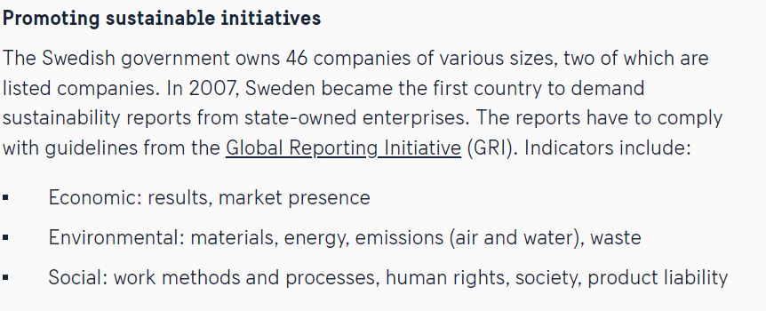

—--------------------------------------------------------------------------------------------------------

Small companies are often the ones who do not think as much about sustainability so therefore this tool would be good since you can assume that the entrepreneurs are starting small.

Extra questions:

—Are raw materials used? Are there metal emissions? Is metal scrap recycled into pure fraction?

–Does the design of the product contribute to the deterioration of nature due to noise, odors or emissions during use and/or maintenance?

–-Are there emissions of greenhouse gases due to transport of the product, material or service from the side of the business?

—Are there emissions or waste in the end-of-life cycle that are collected in nature?